

Student Details

Student Name: NELIUS NYAMBURA CHEGE

Admission Number: BSCCS/2024/57518

Course: COMPUTER SCIENCE

Unit Code: BIT 3208

Unit Name: ADVANCED WEB DESIGN AND DEVELOPMENT

Lecturer Name: NYORO MICHAEL

Semester: MAY/AUG 2026

Project Details
Project Title: CLINIC BOOKING SYSTEM

Selected Technologies PHP + MySQL

Online Portfolio
GitHub Repository Link: https://github.com/nyamburanelius472-source/clinic_system

Table of Contents
WEEK 1: Local Environment Setup 4
1.1 Installation and Testing of Local Development Environment 4
Fig 1: Installation of XAMPP/WAMP 4
Fig 2: Apache and MySQL Running 4
Fig 3: Localhost Test Page 5
Fig 4: Hello World Test 5
Fig 5: Database Connection Test 6
WEEK 2: Wireframes and GUI Design 7
2.1: User Interface Planning and System Design 7
Fig 1: Wireframes 7
Fig 2: Dashboard Layout Design 8
Fig 3 Mobile View Mockup 9
Fig 4: Color Theme and Navigation Structure 10
Fig 5: GUI Prototype in Figma/canva/Draw.io 10
WEEK 3: JAVASCRIPT AND PHP BASICS 11
3.1: Frontend Interaction and Backend Foundations 11
Fig 1: JavaScript Form Validation 11
Fig 2: Password Strength Checker 11
Fig 3: PHP Syntax Practice 12
Fig 4 Database Connection Script 12
Fig 5: Dynamic User Input Handling 12
Student Reflection 12
WEEK 4: DELIVARABLES 13
Fig 1: Login form screenshots 13
Fig 2: Form validation screenshots 13
Fig 3: PHP Processing Screenshots 14
Fig 4 Folder Structure screenshot 14
Fig 5: Database connection screenshot 15
Fig 6: Code Snippets 15
WEEK 5: Database Screenshots 16
Fig 1: Database Screenshot 16
Fig 2 Table creation Screenshots 16
Fig 3: CRUD operations 17
Fig 4 Login Database Integration 18
Fig 5 SQL Query screenshot 18
WEEK 6: Database Intergration and CRUD Operations, 19
Fig 1: Database Design / Normalization 19
Fig 2: CREATE 19
Fig 3: READ 20
Fig 4: UPDATE 20
Fig 5: DELETE 21
WEEK 7: User Authentication and Session Management 22
Fig 1: Hashed Passwords 22
Fig 2: Login Form with Remember me Checkbox 22
Fig 3: Cookie Working 23
Fig 4: Session management 23
Fig 5: Role-based Access 24

WEEK 1: Local Environment Setup

1.1 Installation and Testing of Local Development Environment

Fig 1: Installation of XAMPP/WAMP

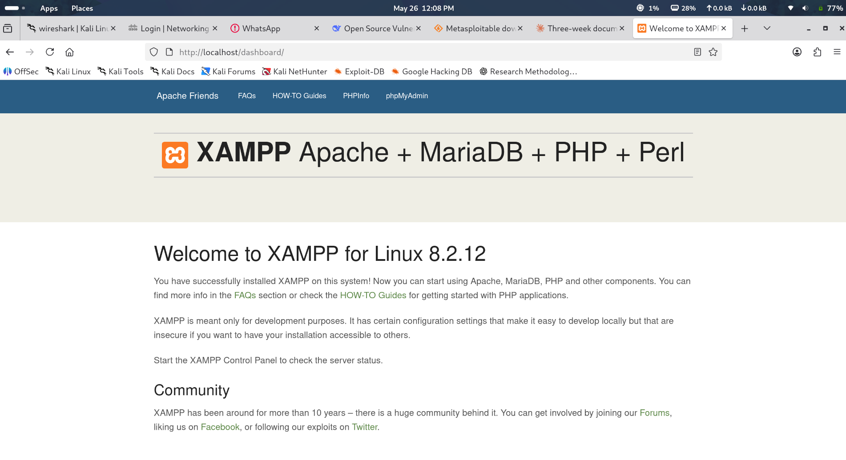

Fig 2: Apache and MySQL Running
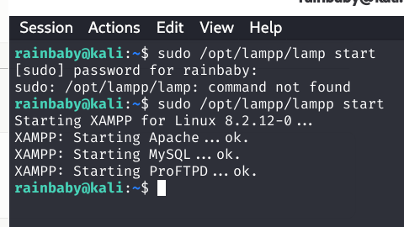

Fig 3: Localhost Test Page



Fig 4: Hello World Test
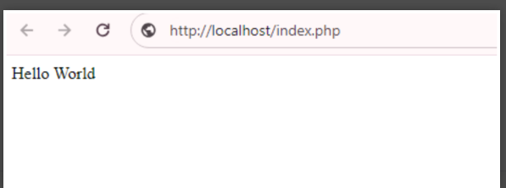

Fig 5: Database Connection Test

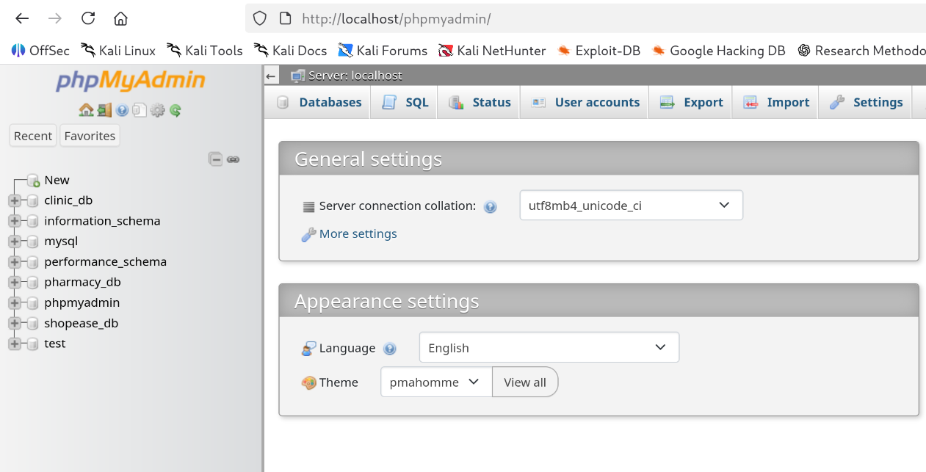

Student Reflection
Successfully set up local development environment XAMPP. Learned the importance of properly configuring Apache and MySQL services before development. The main challenge was just learning new commands to make xampp executable in kali Linux there was no solving port conflicts. The screenshots show all components are functioning properly.

WEEK 2: Wireframes and GUI Design

2.1: User Interface Planning and System Design

Fig 1: Wireframes
Login wireframe
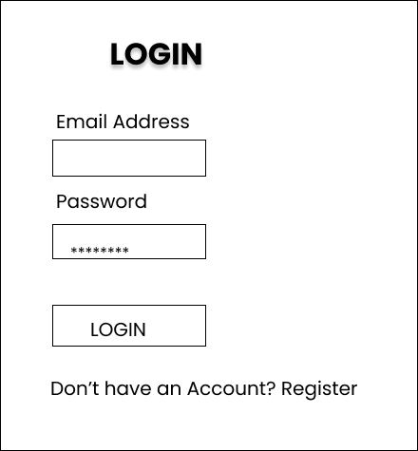
Homepage Wireframe
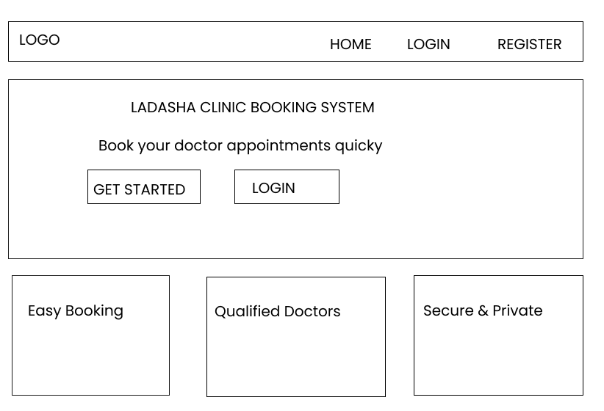

Fig 2: Dashboard Layout Design
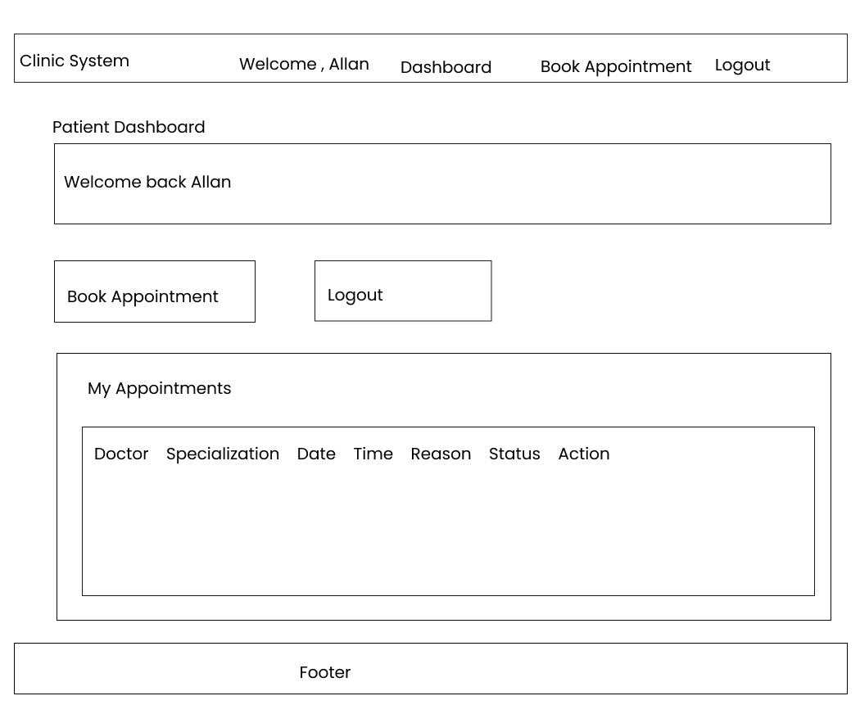

Fig 3 Mobile View Mockup

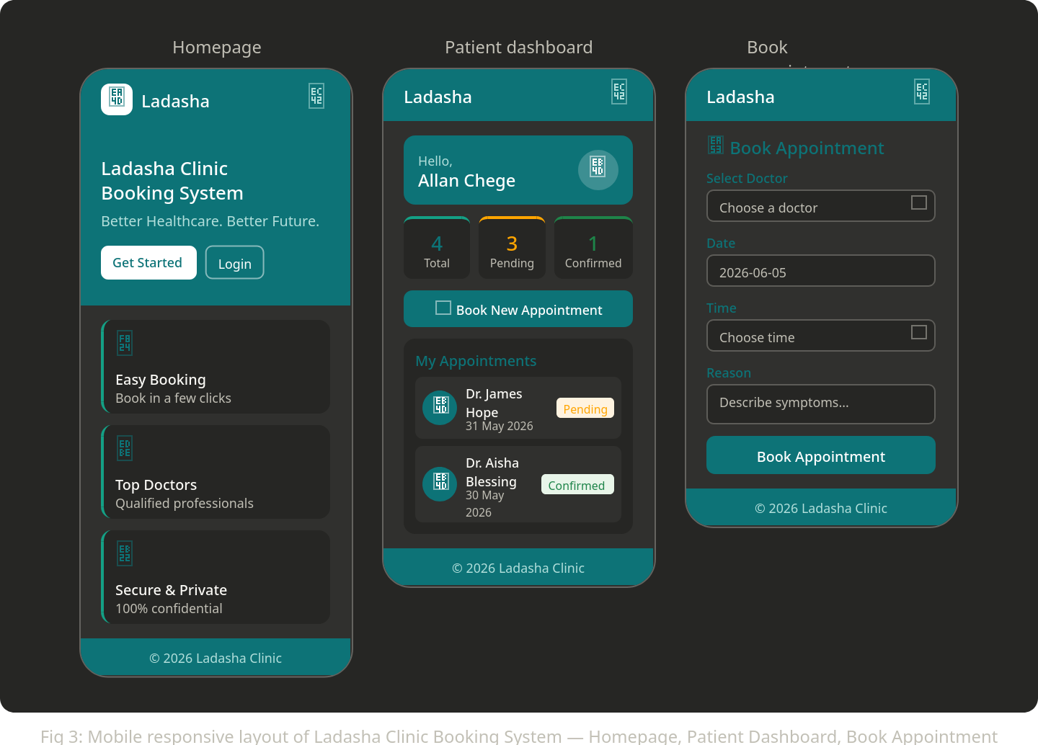

Fig 4: Color Theme and Navigation Structure
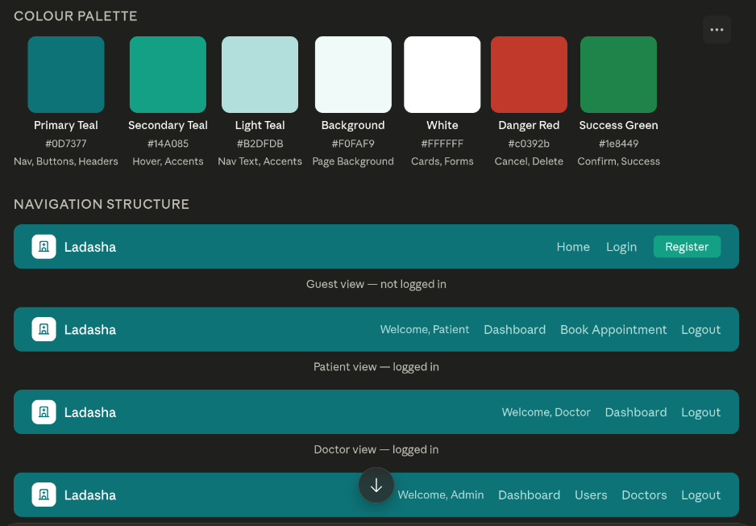

Fig 5: GUI Prototype in Figma/canva/Draw.io
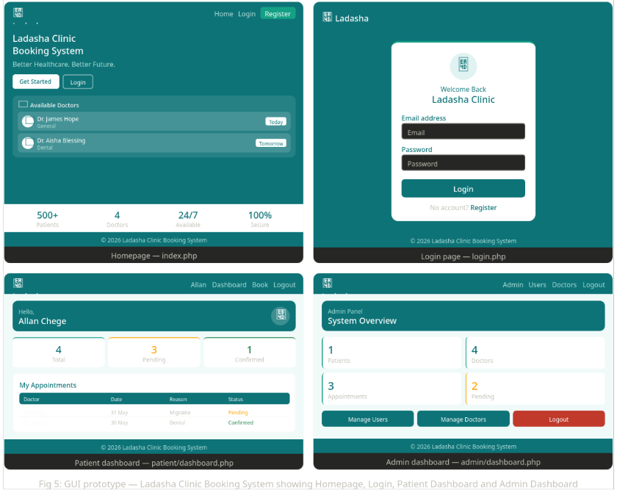
Student Reflection
Drew wireframes using Figma to guide me during development, the mobile mockup shows the mobile responsive layout planned for the Clinic Appointment Booking System, ensuring accessibility across devices. The color scheme and navigation structure chosen is teal and white reflecting a professional medical environment. A high-fidelity prototype designed before coding began. Three user roles defined are Patient, Doctor, and Admin each with distinct access levels. This planning phase ensured a clear development roadmap and prevented design conflicts during the coding phase in the later weeks.

WEEK 3: JAVASCRIPT AND PHP BASICS

3.1: Frontend Interaction and Backend Foundations

Fig 1: JavaScript Form Validation
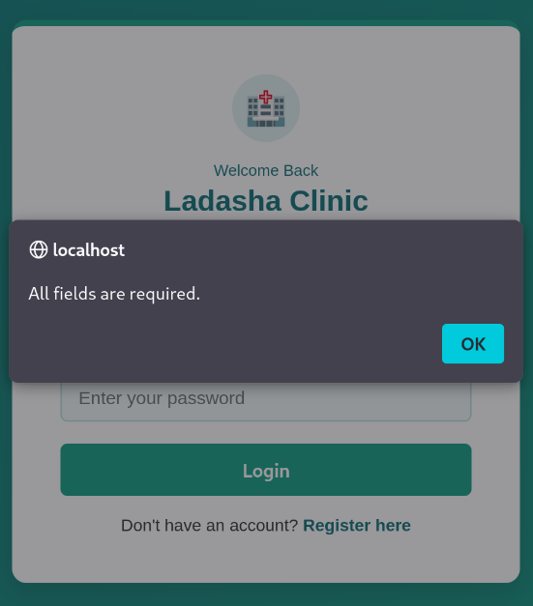

Fig 2: Password Strength Checker
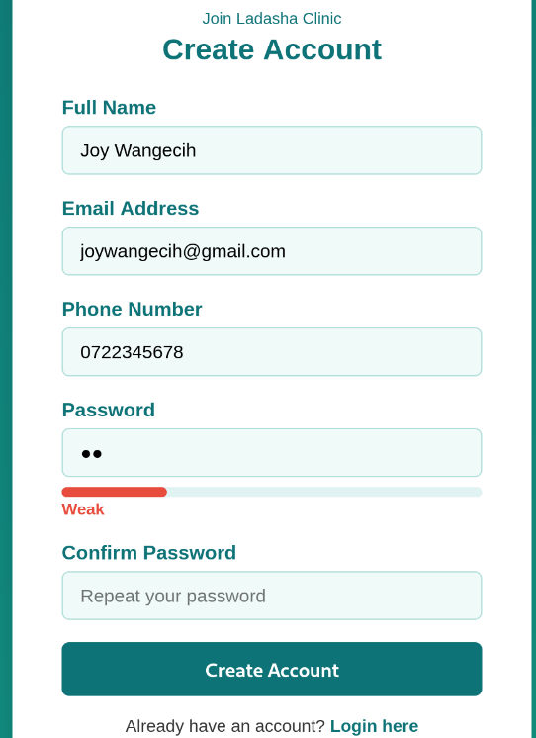
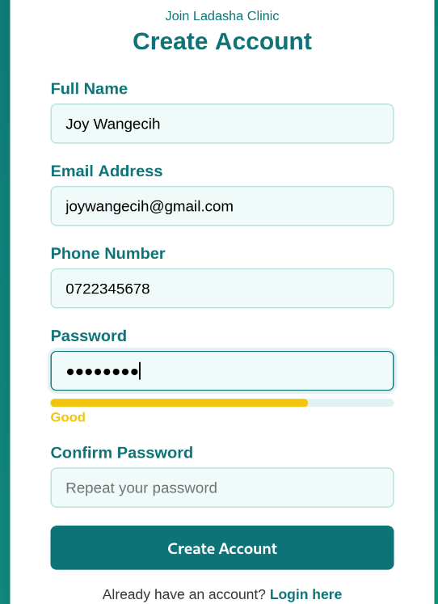

Fig 3: PHP Syntax Practice

Fig 4 Database Connection Script
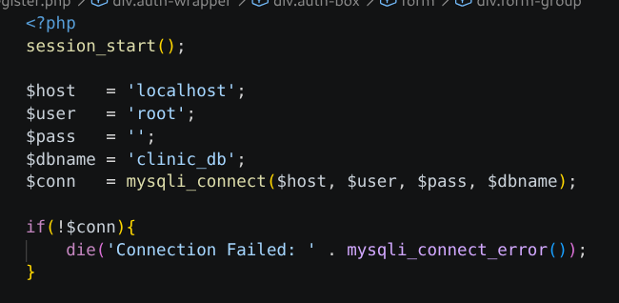
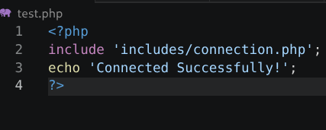

Fig 5: Dynamic User Input Handling
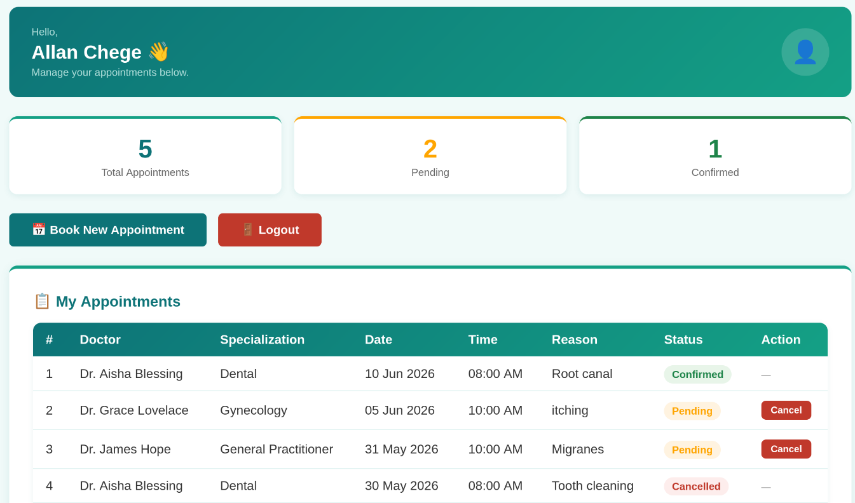

Student Reflection
In week three, I implemented JavaScript form validation on the registration page to prevent empty submissions and invalid email formats. The password strength checker evaluates passwords based on length, Uppercase letters, numbers and special characters with real-time visual feedback using a colored progress bar. For php foundations, I practiced variables, conditionals and superglobals session using code from register. Php and login .php. The database connection script uses mysqli_connect () to link PHP with MySQL and dynamic user input handling captures login credentials, verifies hashed passwords using password verify (), starts sessions, and displays personalize welcome messages on role-specific dashboards.

WEEK 4: DELIVARABLES

Fig 1: Login form screenshots
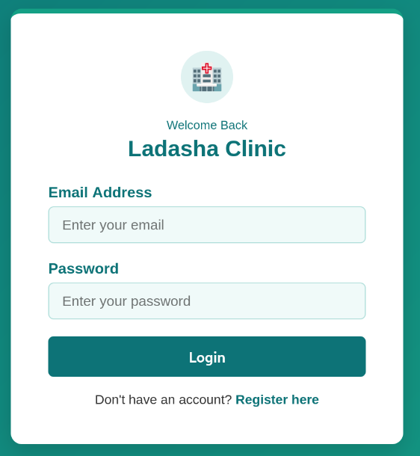

Fig 2: Form validation screenshots

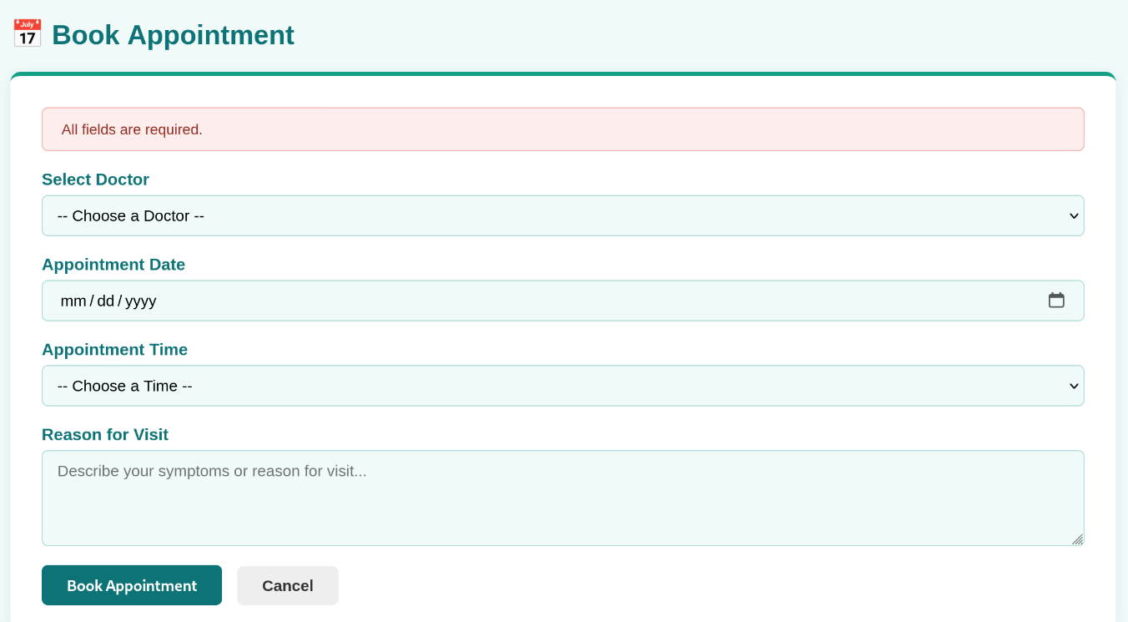

Fig 3: PHP Processing Screenshots

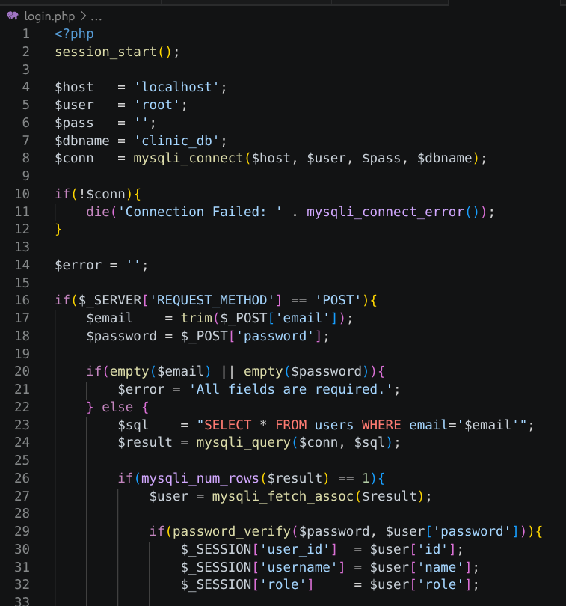
Fig 4 Folder Structure screenshot
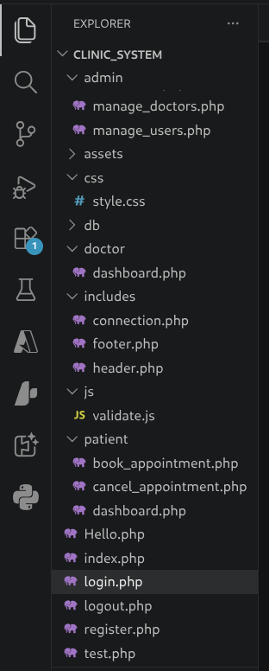

Fig 5: Database connection screenshot
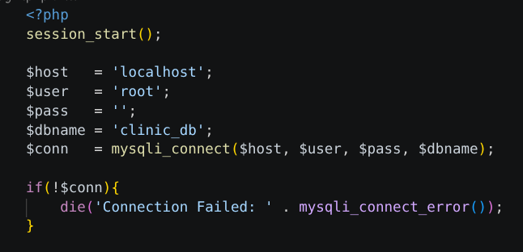

Fig 6: Code Snippets
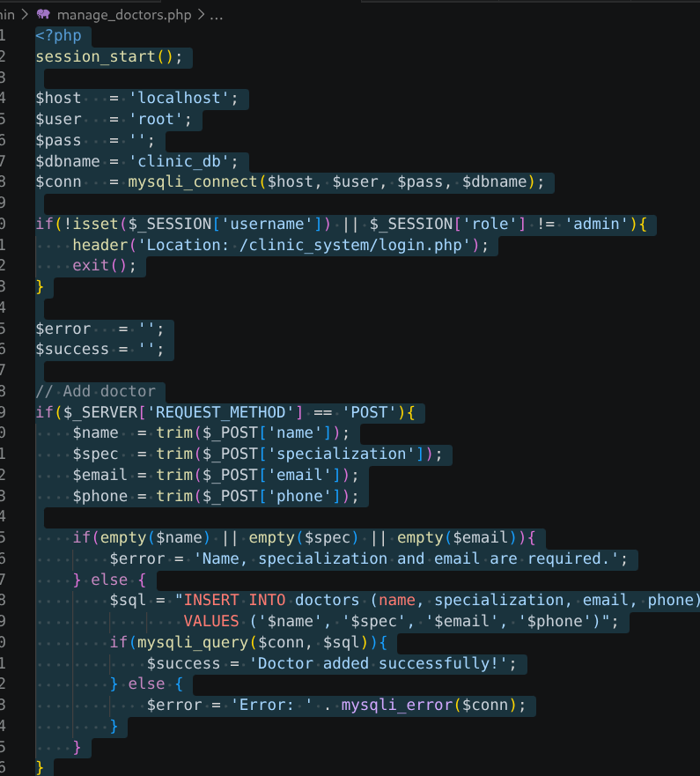
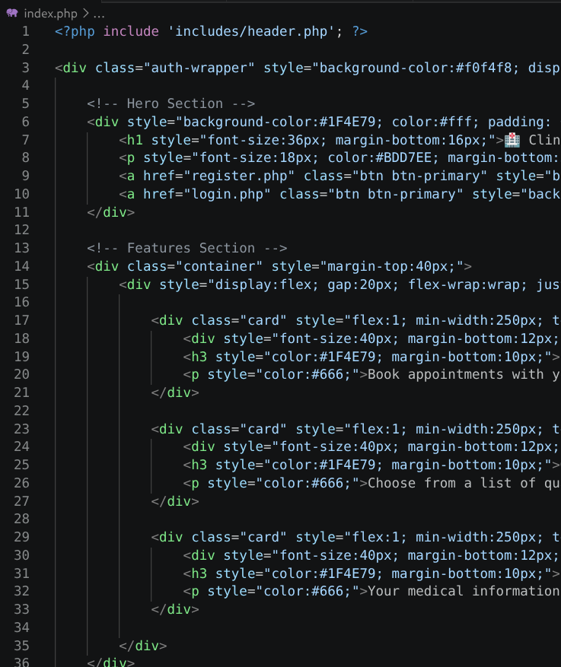
Student Reflection
This week I built the backend foundation of the Ladasha Clinic Booking System using PHP and MySQL on Kali Linux with XAMPP. I created the registration form where patients create accounts with hashed passwords. The login system uses mysqli_connect () to query the users table and password verify () to authenticate credentials. Sessions were implemented using session start () and $_SESSION to keep users logged in across pages. The patient dashboard was protected using a session guard that redirects unauthenticated users back to login.

WEEK 5: Database Screenshots

Fig 1: Database Screenshot

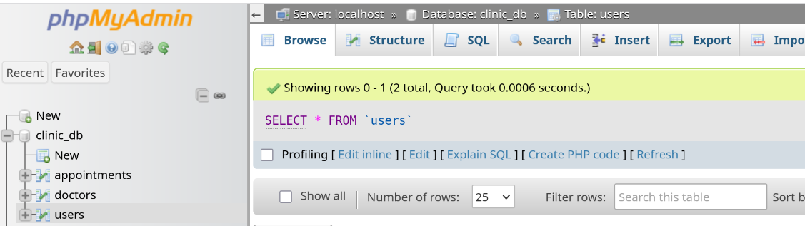

Fig 2 Table creation Screenshots

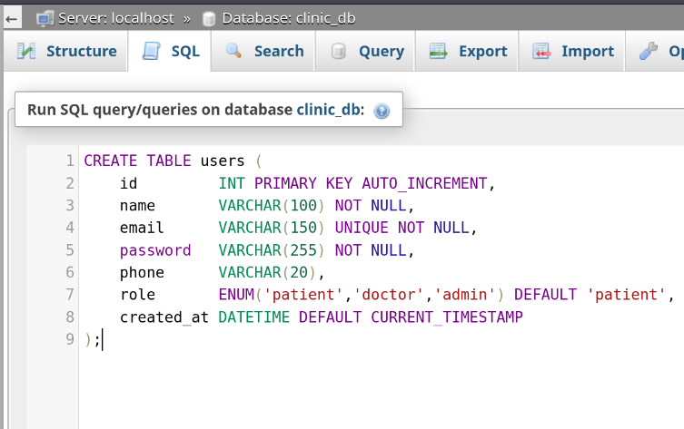
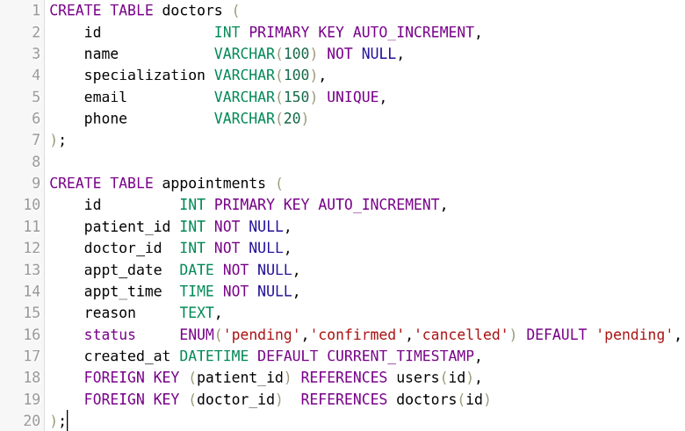

Fig 3: CRUD operations
CRUD OPERATION CREATE
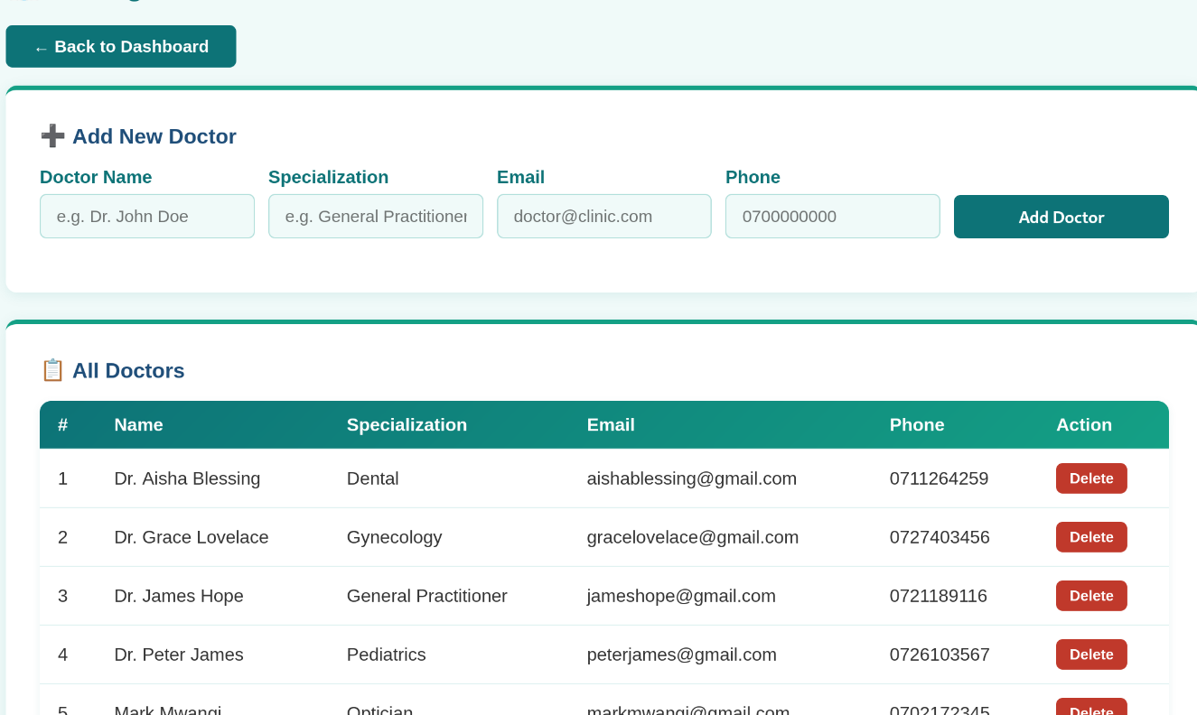
CRUD OPERATION DELETE
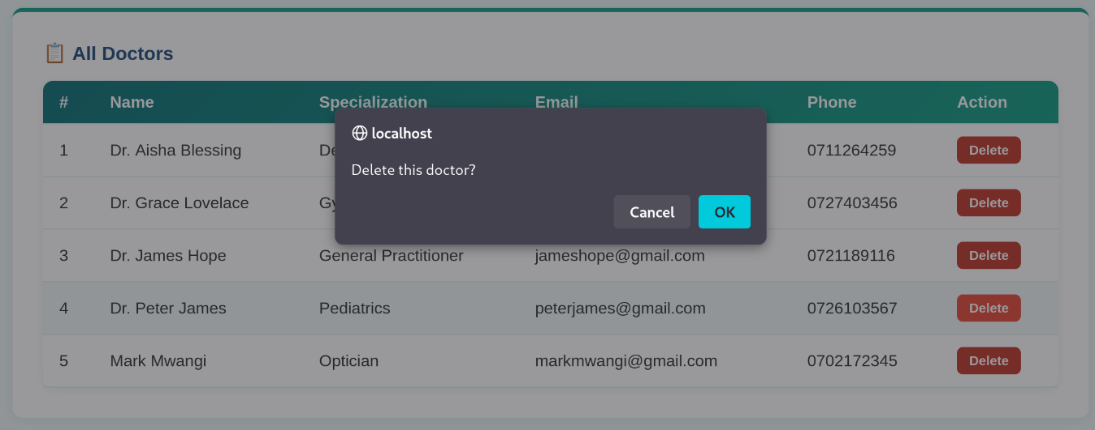

Fig 4 Login Database Integration
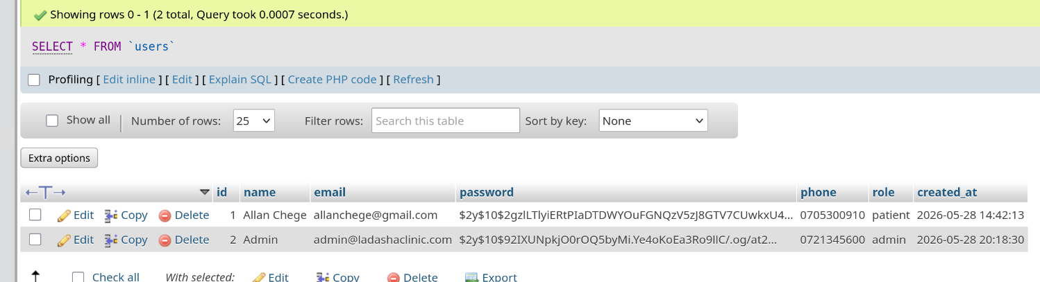

Fig 5 SQL Query screenshot
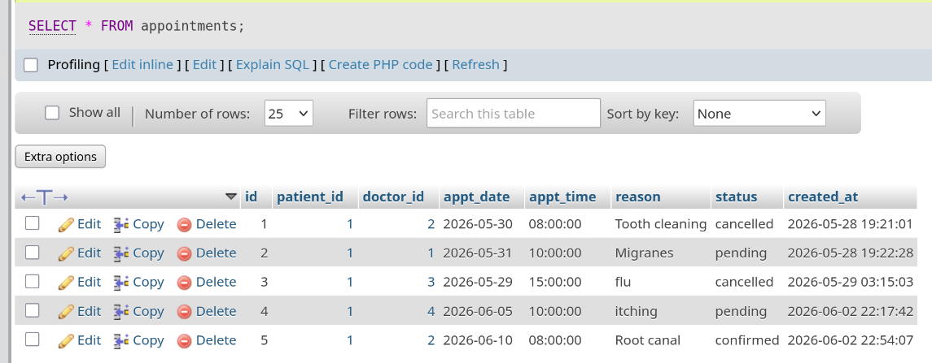
Student Reflection
In week five I created the database tables for the Ladasha Clinic Booking System. I made three tables’ users, doctors, and appointments using SQL in phpMyAdmin. I then connected the forms to the database so when a patient books an appointment it saves in the appointments table. I could also view all appointments on the dashboard and cancel them. The admin page shows the total number of patients, doctors and appointments from the database. I also added doctor login accounts so doctors can log in and confirm or cancel patient appointments. Everything was saved to my GitHub.

WEEK 6: Database Intergration and CRUD Operations,

Fig 1: Database Design / Normalization
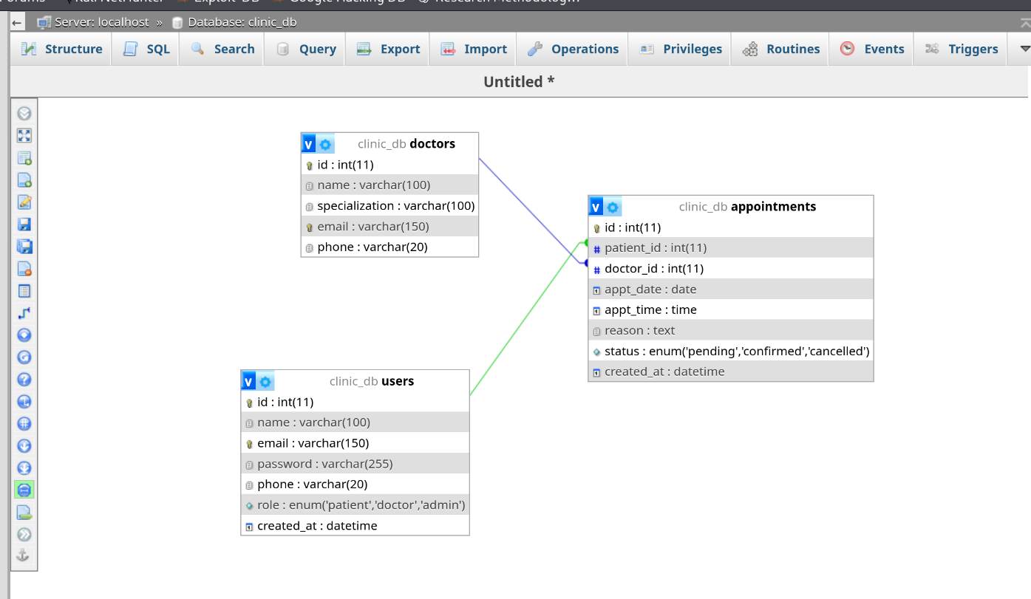

Fig 2: CREATE
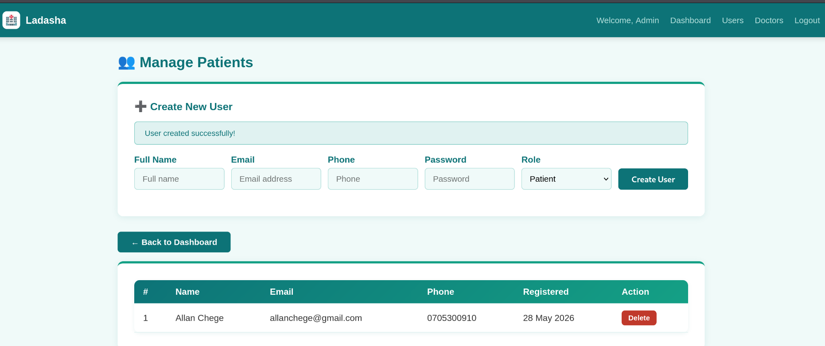

Fig 3: READ
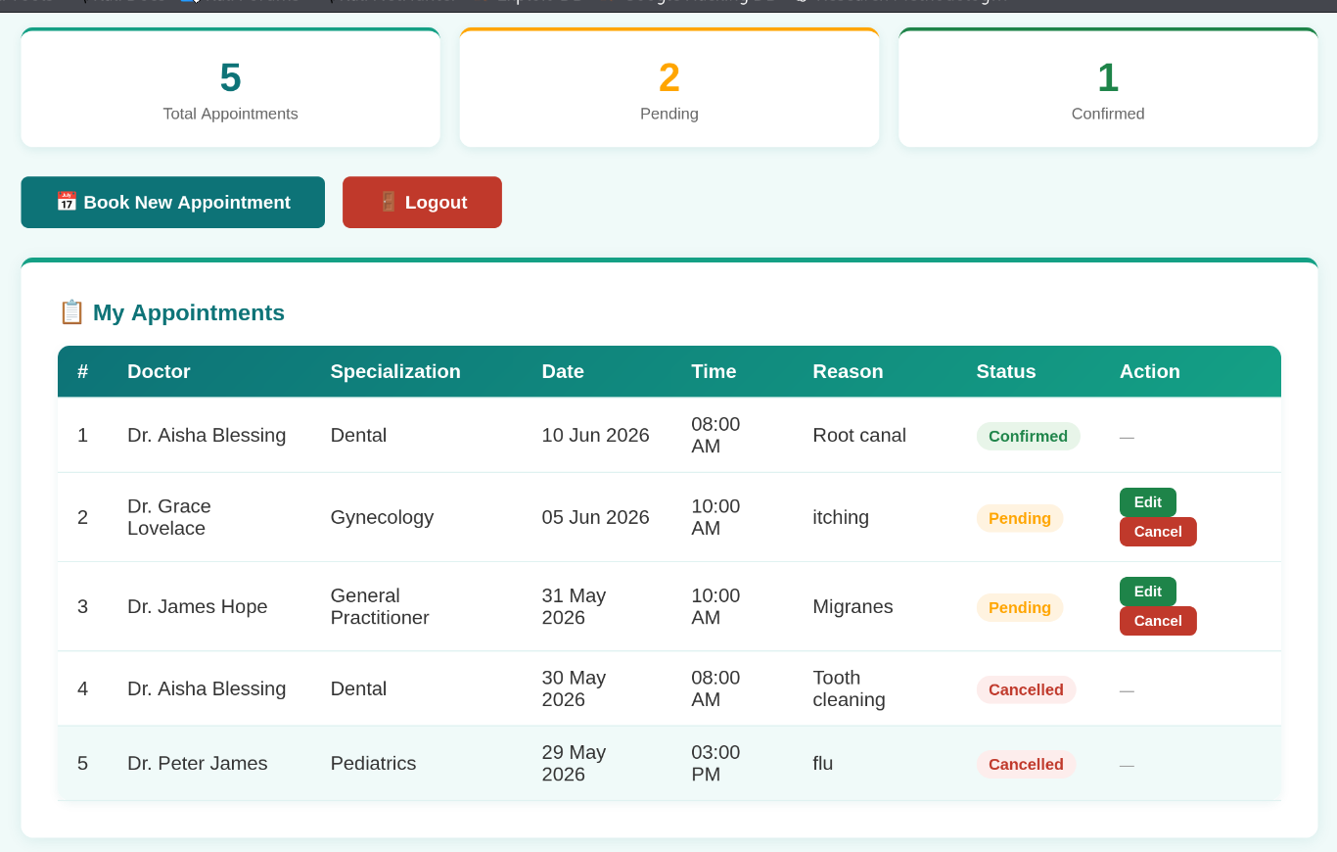

Fig 4: UPDATE
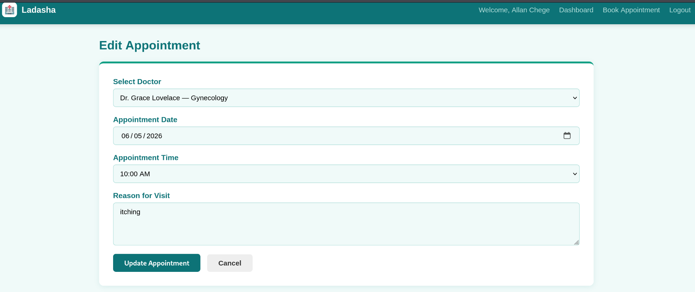

Fig 5: DELETE

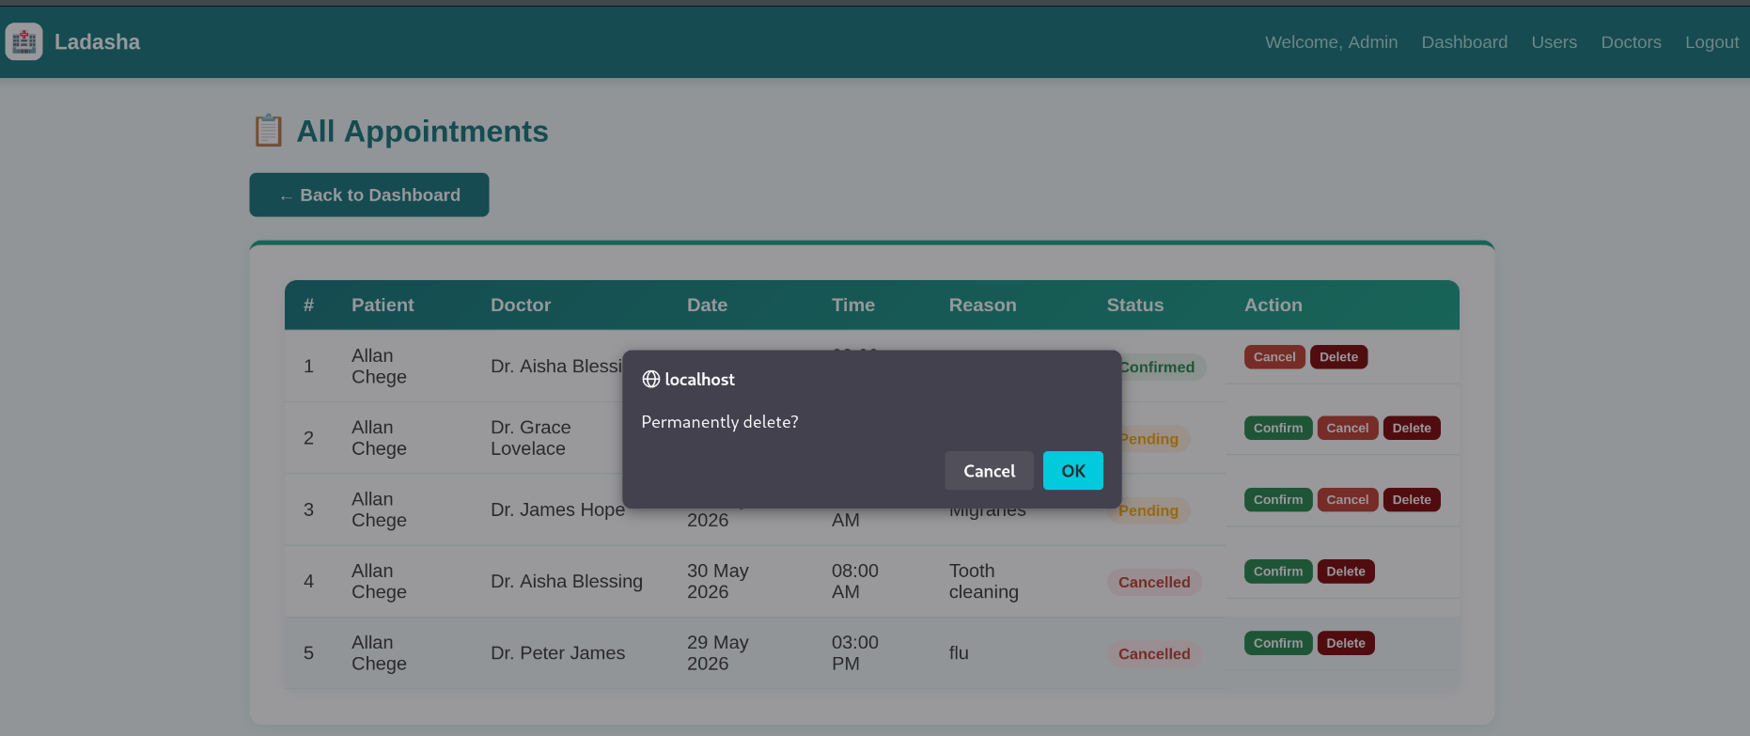
Student Reflection
This week I worked on database integration for the Ladasha Clinic Booking System. I demonstrated all four CRUD operations using PHP and MySQL. For Create, patients can book new appointments which are saved into the appointments table. For Read, all appointments are fetched and displayed on the patient dashboard using a SELECT JOIN query. For Update, patients can now edit their pending appointments and doctors can confirm or cancel them. For Delete, the admin can permanently remove appointment records. The database has three tables — users, doctors and appointments — which are normalized to third normal form using foreign keys.

WEEK 7: User Authentication and Session Management

Fig 1: Hashed Passwords
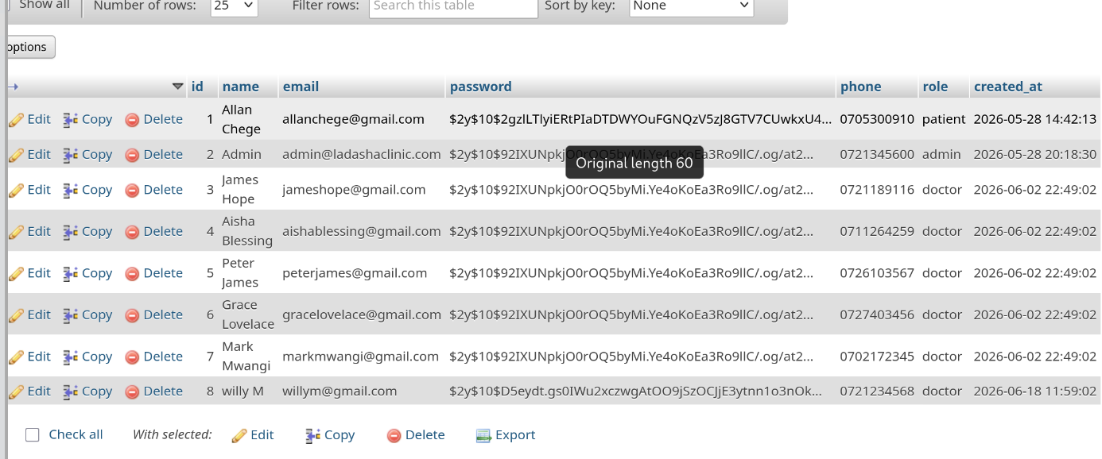

Fig 2: Login Form with Remember me Checkbox
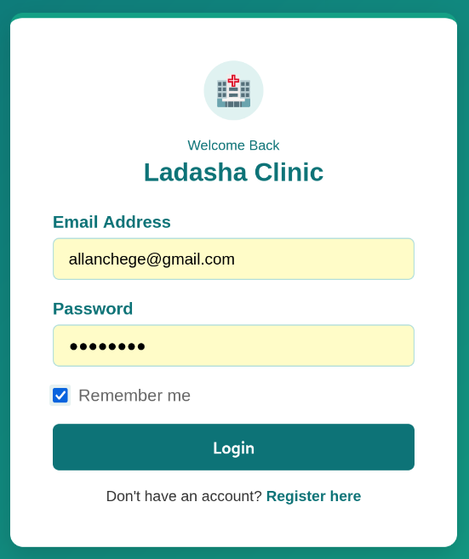

Fig 3: Cookie Working
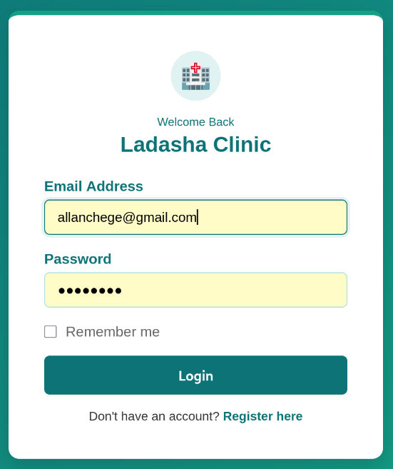

Fig 4: Session management
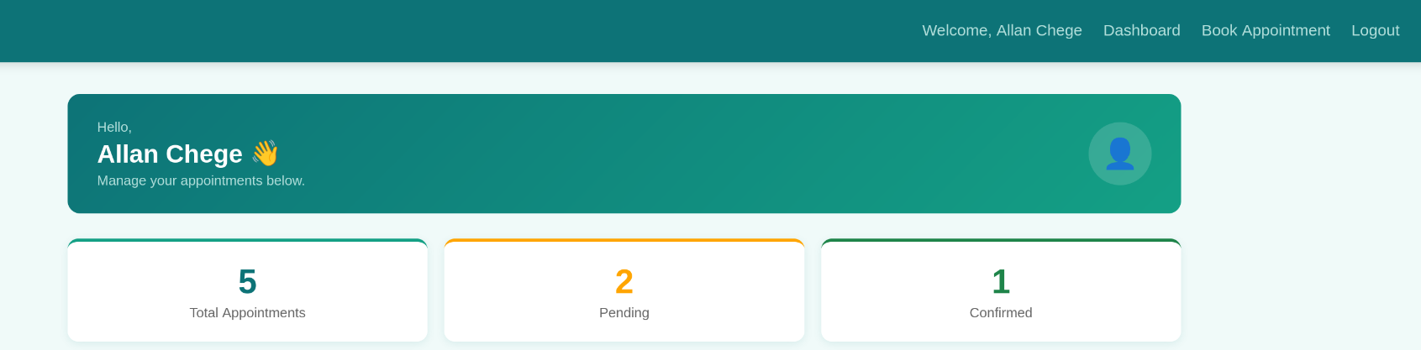

Fig 5: Role-based Access
Patient dashboard
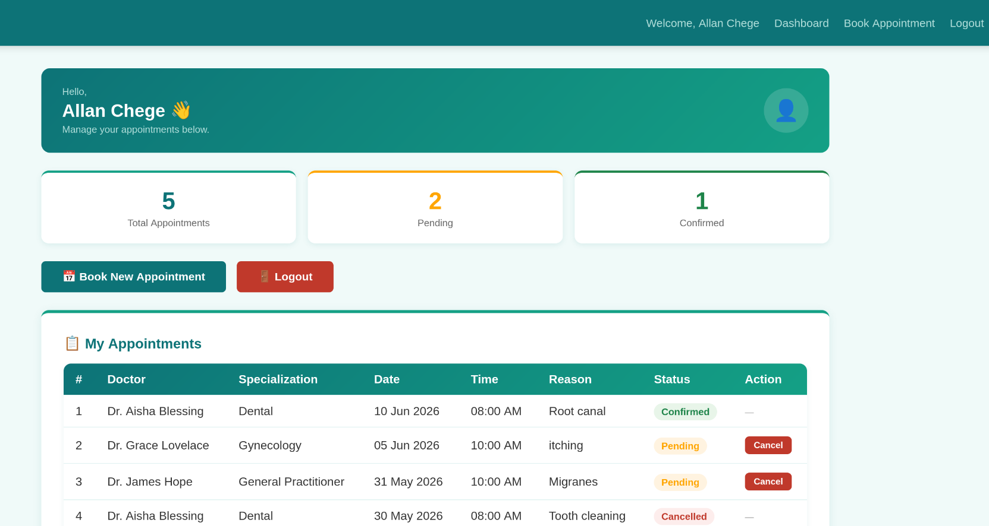

Doctors dashboard
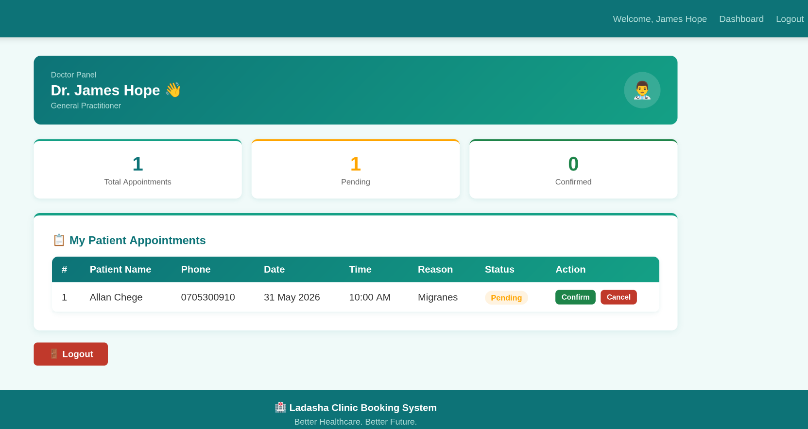

Admin dashboard
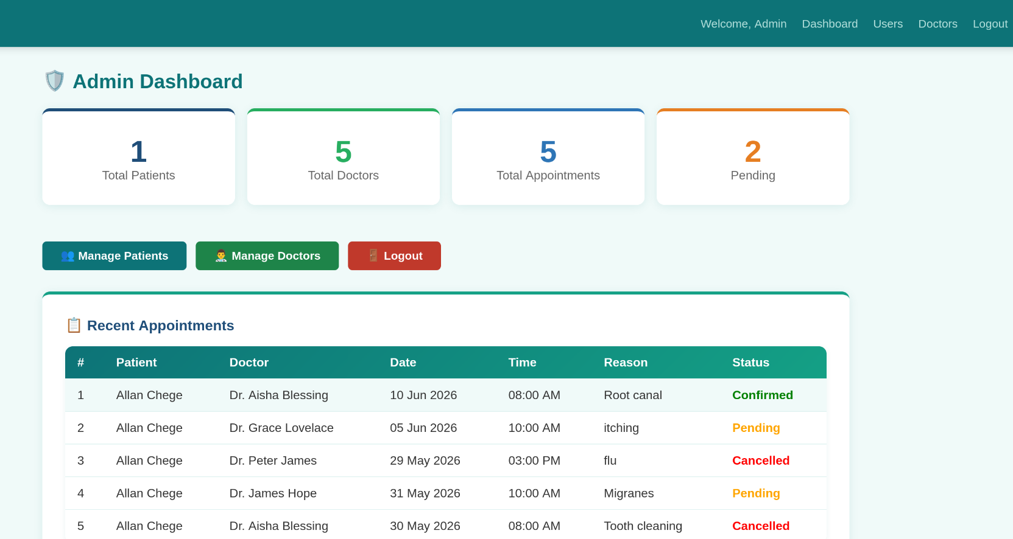
Student Reflection
Implemented user authentication and session management in the Ladasha Clinic Booking System. When a patient registers, the password is hashed using password_hash() before being saved so no plain text passwords are stored in the database. The login system uses password_verify() to check the entered password against the hashed one. After successful login, a session is created using session_start() and $_SESSION to keep the user logged in across pages. A Remember Me cookie was added using setcookie() which saves the user email for 30 days. The system has three user roles Admin, Doctor and Patient each with their own protected dashboard.

